PVP 3 : system of pvp: arena, challenge and the map of god

Dire a combien vous en êtes dans le pvp d'arene, par challenge et par map of gold et dementia system affiche de skill avec v pour accomplie et x ce qui resta accomplir en expliquant ce que sa donne comme ppoint et il y aura une phrase pour savoir ou vous en êtes par rapport aux autres rang: Tout les rang il y aura une image supplémentaire: pour le pvp sa sera des etoile et pour le dementai une tete de demon plus en plus moche et diabolique.

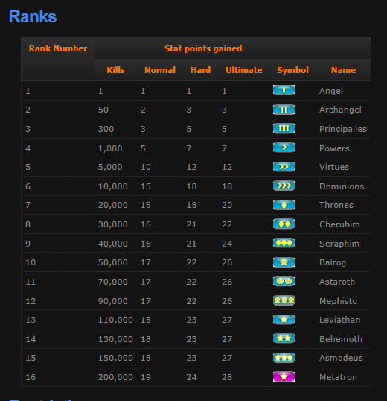

Honneur sera obtenu en pvp 1v1: calculer par 1 x fois le niveau de l'adversaire et +25% de plus tout les 5 niveau supplementaire au sien

|  |  |
| --- | --- |
| **Level of opposent** | **Honor get** |
| +15 and more | 1.75x the level of enemy |
| +10 to 14 | 1.50x the level of enemy |
| +5 to 9 | 1.25x the level of enemy |
| -4 to +4 | 1.0x the level of enemy |
| -5 to -9 | 0.75x the level of enemy |
| -9 to 14 | 0.50x the level of enemy |
| -15 and less | 0.25x the level of enemy |

Example: you are level 36, you just have killed a opponent of level 48, your opponent have 12 level of more than you (10 to 14 level of more than you), that is to say you will receive 48 x1.5 honor, you will receive 72 honor. This is how the honor is calculated:

Where to get honor in the arena?

What is the arena?

How does it work to use a skill?

Kill and become stronger system?  
What is this system?  
This system will raise the talisman attributes with killing other character in game. That is to say more your characters will kill other players in game and more your character will become stronger.  
  
What is a talisman?  
  
Where to fight players?  
It is possible to fight players in a PVP (players versus players) map that call the map of god. Its the only place where you can attack players without they accept a duel. This map is very large and is not composed of monsters that is to say there is only players in this map. When a players enter in the map of god, he is immediately directed in a team with an automatically balancing of team. There is just 2 different team who are the Evil (red team) and the Angel (blue team). To know what team is the best and what are the players score there will be a board of score of team who will be composed of: kill and death of each team with who are in all team, what class, kill and death of each players in the map.  
  
Image of board of team score:  
Evil team, sum of kill of all players, sum of death of all players  
Players of evil team, Class, World Rank of PVP, kills of players, death of players, average level, average ratio  
Angel team, sum of kill of all players, sum of death of all players, level of players, ratio of players  
Players of angel team, Class, World Rank of PVP, kills of players, death of players, level of players, ratio of players  
  
What is the world rank of pvp?  
This is the world ranking of the person who did the most kill in the map of god.  
  
What is a ratio?  
This is the numbers of kill dividied by the number of death  
  
what is an automatically balancing of team?  
When a players will join the map of god he will automatically directed in the team who have the lowest numbers of kill. This is possible to know it with the board of team score.   
  
Image + example  
  
Where to find all map of god?  
There are 2 to 3 map of god in each difficulty mode who will situated in town such as telumin, terembora, lastvilalge etc.. Telumin will mean the first town of the game, terembora will mean the middle of the game and last village will mean the end game,:

|  |  |  |
| --- | --- | --- |
| **Level requiered to join** | **Difficulty mode** | **Location** |
| 0-10 | Normal | Telumin |
| 10-20 | Normal | Terembora |
| 20-30 | Normal | Last Village |
| 30-40 | Nightmare | Telumin |
| 40-50 | Nightmare | Last Village |
| 50-60 | Hell | Telumin |
| 60-70 | Hell | Last Village |
| 70-80 | Uber | Telumin |
| 80-90 | Uber | Terembora |
| 90-100 | Uber | Last village |

What is a difficulty mode?  
  
How many kill does players need to upgrade their talisman attribute percent?  
To upgrade their talismans attribute percent players have to kill other players in the map of god. This is how will vary the charm attribute percent:

|  |  |
| --- | --- |
| **Numbers of kill** | **Percent of better talisman attribute** |
| 10 | 5% |
| 25 | 10% |
| 100 | 15% |
| 200 | 20% |
| 500 | 25% |
| 1 000 | 30% |
| 2 500 | 35% |
| 5 000 | 40% |
| 10 000 | 45% |
| 20 000 | 50% |
| 30 000 | 55% |
| 40 000 | 60% |
| 50 000 | 65% |
| 60 000 | 70% |
| 75 000 | 75% |

Numbers of kill need, Percent of better talisman attribute percent  
  
RANK System  
what is a rank system?  
A rank system is a proceded to know who are the best in a specific branch in game to compare our with the others  
  
What are all rank who will available?  
The rank who will be available will be:

|  |  |  |  |  |  |  |
| --- | --- | --- | --- | --- | --- | --- |
|  | **Online** | **Offline** | | **Class** | **Name Research** | |
| Level |  |  | |  |  | |
| Gold |  |  | |  |  | |
| Profession level |  |  | |  |  | |
| Choose of the profession |  |  | |  |  | |
| Honor |  |  | |  |  | |
| Kill |  |  | |  |  | |
| Death |  |  | |  |  | |
| Ratio |  |  | |  |  | |
| Difficulty Progress |  |  | |  |  | |
| Number of compouned |  |  | |  |  | |
| Number of raw + choose of difficulty  Choose the raw |  |  | |  |  | |
| Mini game |  |  | |  |  | |
| Choose of the mini game (score) |  | |  |  | |  |

2 images of crystal saga for example  
  
Switch system  
What is a switch system?  
This system will late the possibility to change all their equipment (only equipment, the talisman can be switched with key) with a key.   
  
What are the keys allowed to change their equipment?  
Players could switch their equipment with the keys F1, F2, F3, F4, F5. Example of kind of item with keys: F1 = Magic Find + Gold Find, F2 = Fast Movement, F3 = Players Versus Players, F4 = Players versus monsters : experience percent + power + cast speed, F5 = Players versus Boss: Stun percent, Fast attack, Fast attack, health percent, health etc...

example Diablo 2 switch weapons

When could you switch your equipment?  
Players can only switch their equipment one time every 30 seconds and items can't reduce this time required so use this switch with prudence!

Synergy system  
what is this system?  
Some skill will be link that is to say when you will raise of level a specific skill you will automatically raise some percnet of damage of a other skill exemple: if you gain 1 level of fireball with mage you will raise wildfire damage of 2% at each level

Le Bocal du Chimiste et le Cercle du Pintagram

What is the chimist Bocal?

This is the emplacement where the raws are sent when you get automatically them

How many chimist bocal there are in game?

There are 4 chimist in game, one for each difficulty mode: The chimist bocal of normal mode is green, nightmare mode is blue, the hell mode is yellow and the uber mode is red. There are a different color to show more instivily what is the difficulty mode where you find your raws.

What are all different bag?

There is 6 bags for items, 1-2, bag for talisman called the cercle of the pintagram, 4 bags for raws

How to get the chimist bocal?

The chimist bocal is gettable in the first main quest in the game